**STEPS FOR UPDATION OF MAKER/CHECKER MOBILE NUMBER ON THE PORTAL**

1)Login using **existing** email ID and password of maker(email ID of branch is the email ID of maker) and for checker login use **existing** mobile number and OTP

In case password of maker is forgotten , click on forgot password and link shall be sent to email ID of branch and password can be reset using that link.

2)Mobile number of maker/checker can be updated by clicking on dropdown on top right corner of page and then clicking on account settings

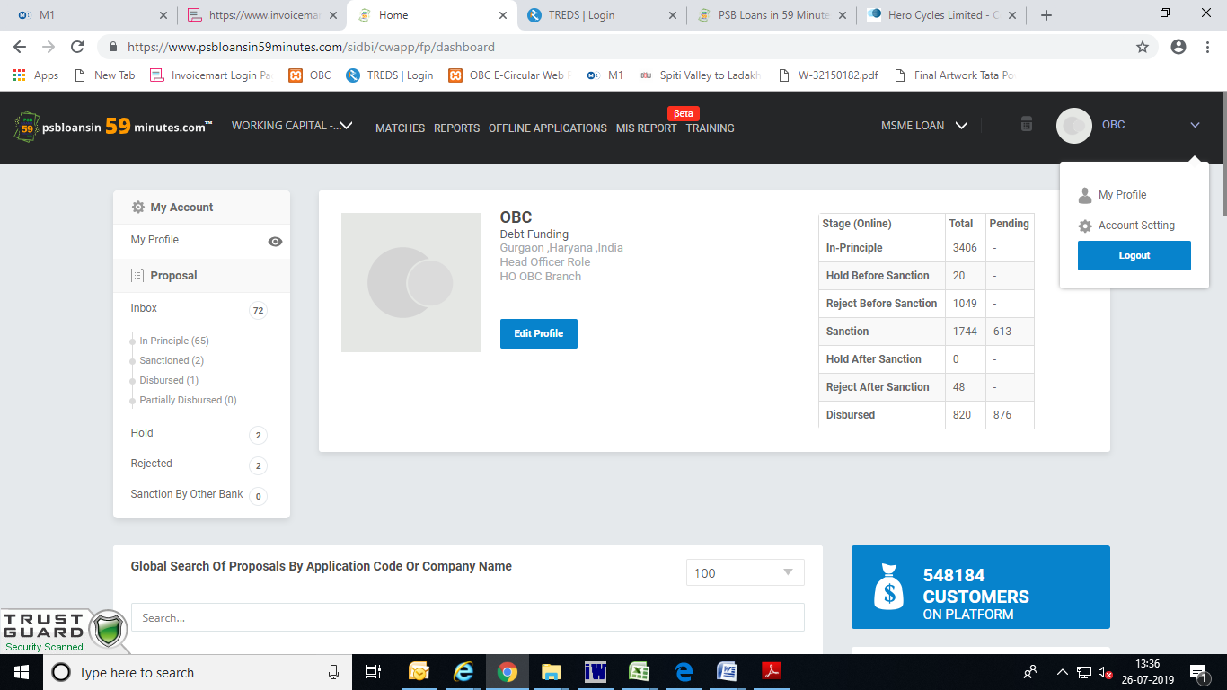Then click on edit contact number and insert new number of maker/checker and save the information, 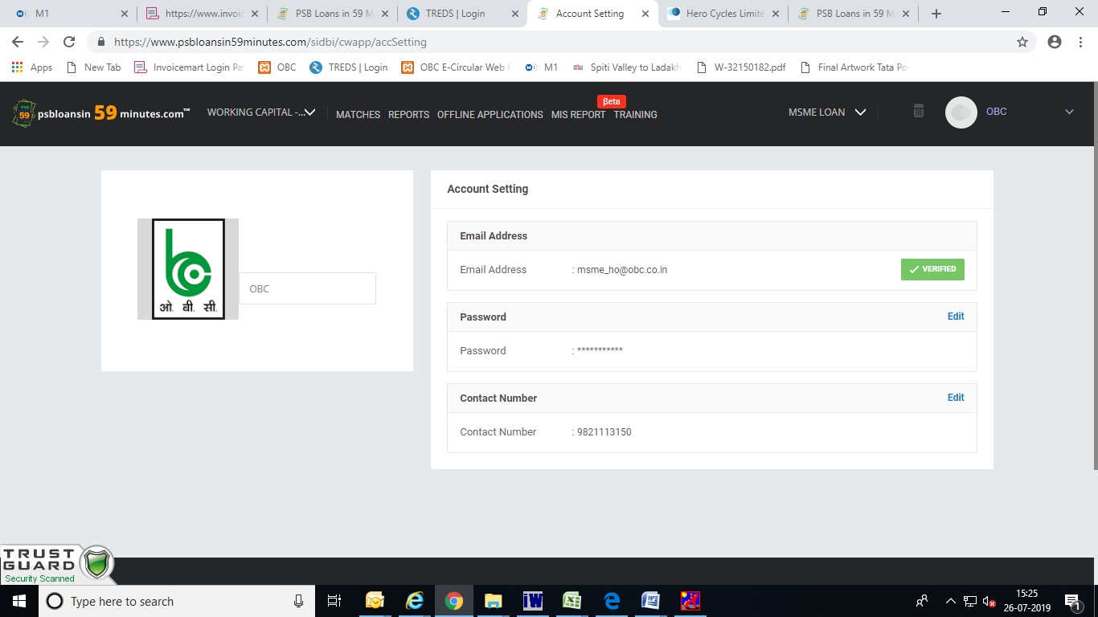

Insert new number and save the number , then next time you will be able to login using new number and OTP

